
You can download, complete and send this form by email - scan the QR code or….
Visit RST website: https://www.riverstourtrust.org/about/rst-policies/iwa-medical-declaration-form/
Request form by emailing: members@riverstourtrust.org
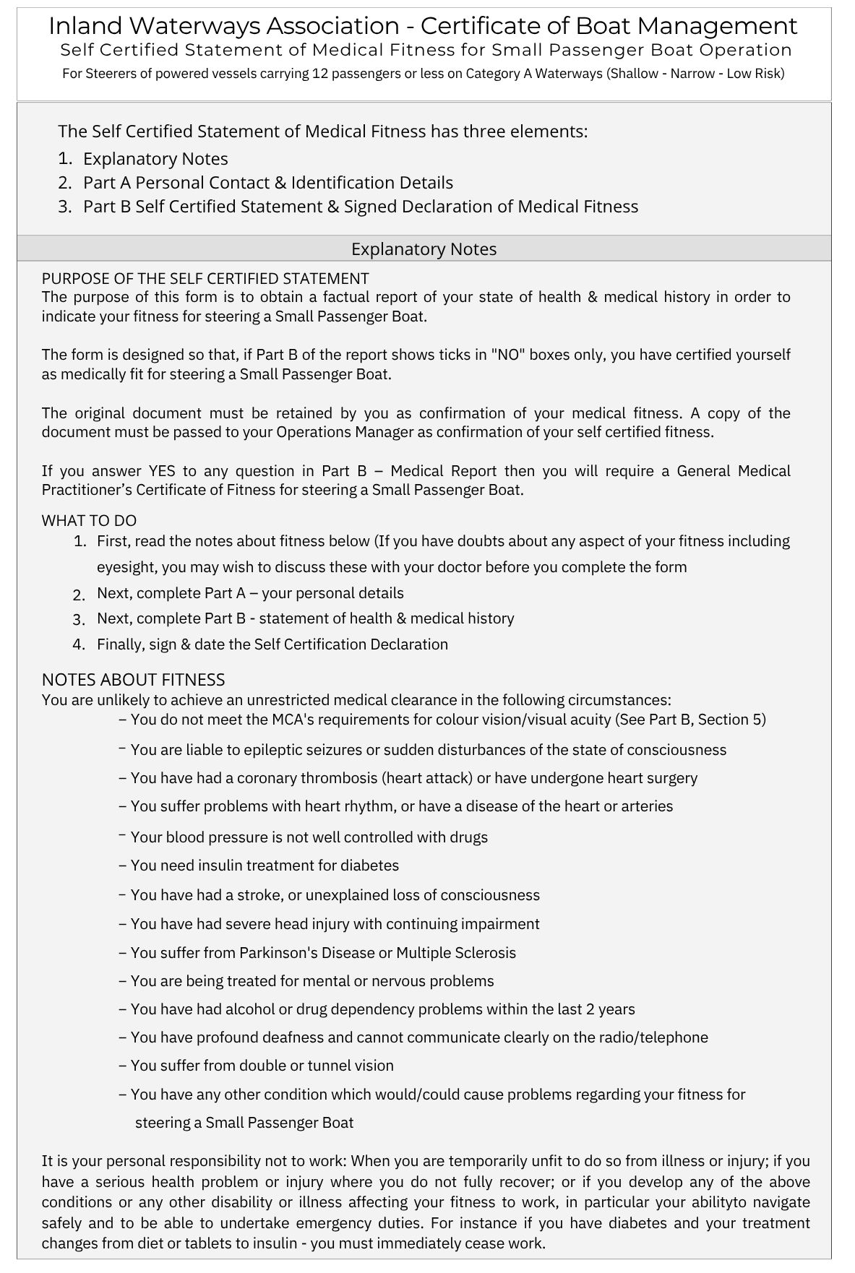
Part A – Applicant’s Contact & Identification Details
Forename | Click or tap here to enter text.
Surname | Click or tap here to enter text.
Date of Birth | Click or tap here to enter text.
Male or Female? | Choose an item.
Full Postal Address | Click or tap here to enter text.
Home Telephone Number | Click or tap here to enter text.
Mobile Telephone Number | Click or tap here to enter text.
Work Telephone Number | Click or tap here to enter text.
Email Address | Click or tap here to enter text.
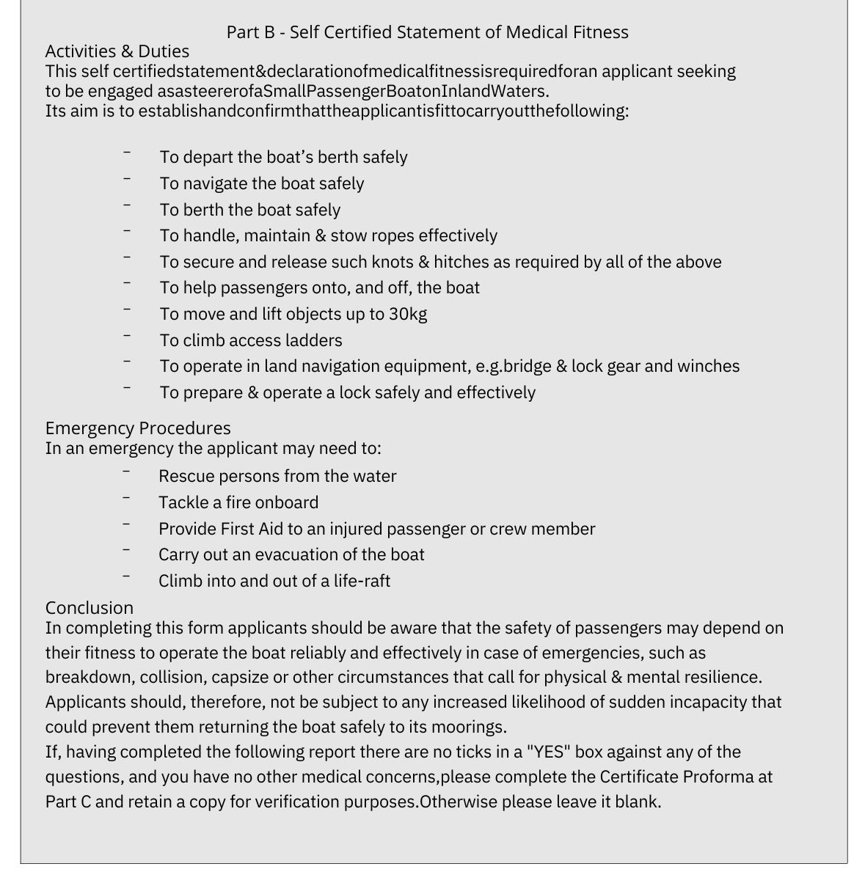
Part B Section 1 - Cardiac | YES | NO
Are you suffering from, or having attacks of angina or receiving continuous treatment to prevent angina from manifesting itself? | ☐ | ☐
Have you undergone coronary artery bypass surgery or coronary angioplasty? | ☐ | ☐
Are you suffering from any disturbance in the rhythm of the heartbeat? | ☐ | ☐
Have you had a cardiac pacemaker implant? | ☐ | ☐
Do you regularly suffer from high blood pressure? | ☐ | ☐
Part B Section 2 – Diabetes | YES | NO
Are you a diabetic requiring insulin treatment? | ☐ | ☐
Part B Section 3 – Nervous System | YES | NO
Have you ever had had any form of epileptic attack? | ☐ | ☐
Do you have a history of black out or impaired consciousness within the last five years? | ☐ | ☐
Do you have a history of, or evidence of, any of the conditions listed 1-7 below? | ☐ | ☐
Stroke / TIA | ☐ | ☐
Sudden and disabling dizziness/vertigo within the last year with a liability to recur | ☐ | ☐
Serious head injury within the last 10 years | ☐ | ☐
Brain tumour, either benign or malignant, primary or secondary | ☐ | ☐
Other brain surgery | ☐ | ☐
Chronic neurological disorders e.g. Parkinson's disease, Multiple Sclerosis | ☐ | ☐
Dementia or cognitive impairment | ☐ | ☐
Part B Section 4 – Psychiatric Illness  Do you have any history of any of the conditions listed 1-6 below? If NO, go to Section 5. | YES | NO
Significant psychiatric disorder within the past 6 months | ☐ | ☐
A psychotic illness within the past 3 years, including psychotic depression | ☐ | ☐
Persistent alcohol misuse in the past 12 months | ☐ | ☐
Alcohol dependency in the past 2 years | ☐ | ☐
Persistent drug misuse in the past 12 months | ☐ | ☐
Drug dependency in the past 2 years | ☐ | ☐
Part B - Section 5 – Sensory | YES | NO
Do you have a colour vision defect | ☐ | ☐
Do you have any defects in the field of vision in either eye? | ☐ | ☐
Do you have profound deafness that prevents communication by radio or telephone? | ☐ | ☐
Part B - Section 6 – Malignant Disease | YES | NO
Do you suffer from malignant disease likely to impair physical or mental fitness to undertake duties in the foreseeable future? | ☐ | ☐
Do you have a history of malignant tumour? | ☐ | ☐
Part B - Section 7 – Musculoskeletal Limitations & Obesity | YES | NO
Do you have insufficient strength and flexibility to perform normal duties such as mooring and lock operations ? | ☐ | ☐
Do you have insufficient strength and flexibility to physically assist other people who have fallen overboard or who need to evacuate the boat in an emergency? | ☐ | ☐
Do you suffer from excessive obesity likely to interfere with the activities listed above or prevent access to areas of the boat with size restrictions? | ☐ | ☐
Do you currently suffer any disability of the spine, limbs or hands likely to limit duties or safety procedures while working? | ☐ | ☐

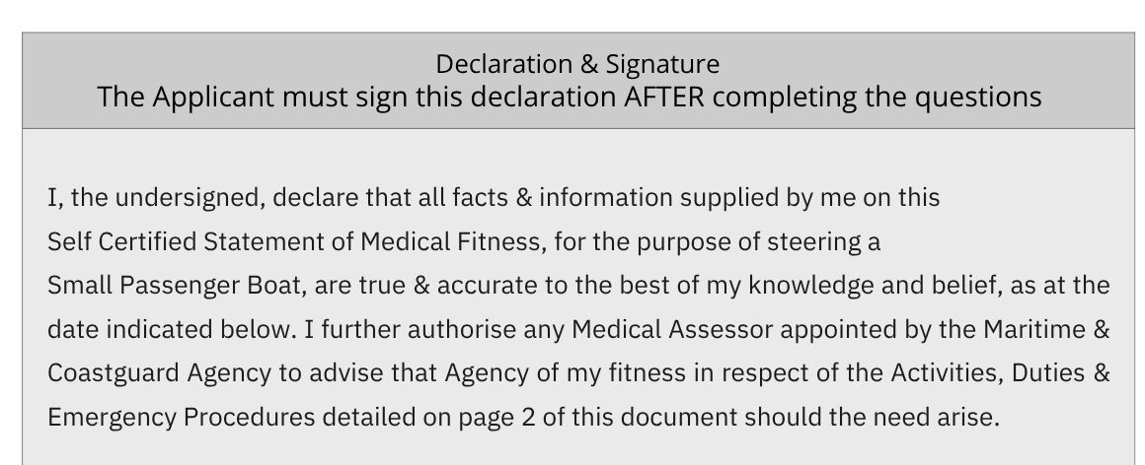
Signature of Applicant:  [for online submission, please upload scan/image of your signature, if possible] | 
Applicant Name: | Click or tap here to enter text.
Date Signed: | Click or tap to enter a date.

Completed form to be returned to River Stour Trust

POST
- The Granary, Quay Lane, Sudbury, Suffolk, CO10 2AN
OR
- RST Visitor Education Centre, Dove House Meadow, Great Cornard, Sudbury, Suffolk, CO10 0GF

EMAIL
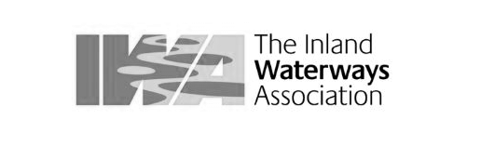

- To: members@riverstourtrust.org

